**Name:**

**Hamza Mehmood Mughal**

**Intern ID:**

**TN/IN02/PY/009**

**Project: Student Result Management System**

**Code:**

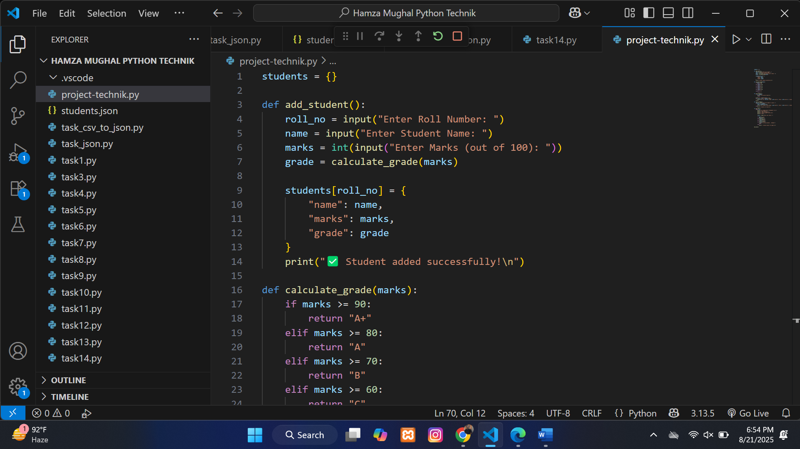

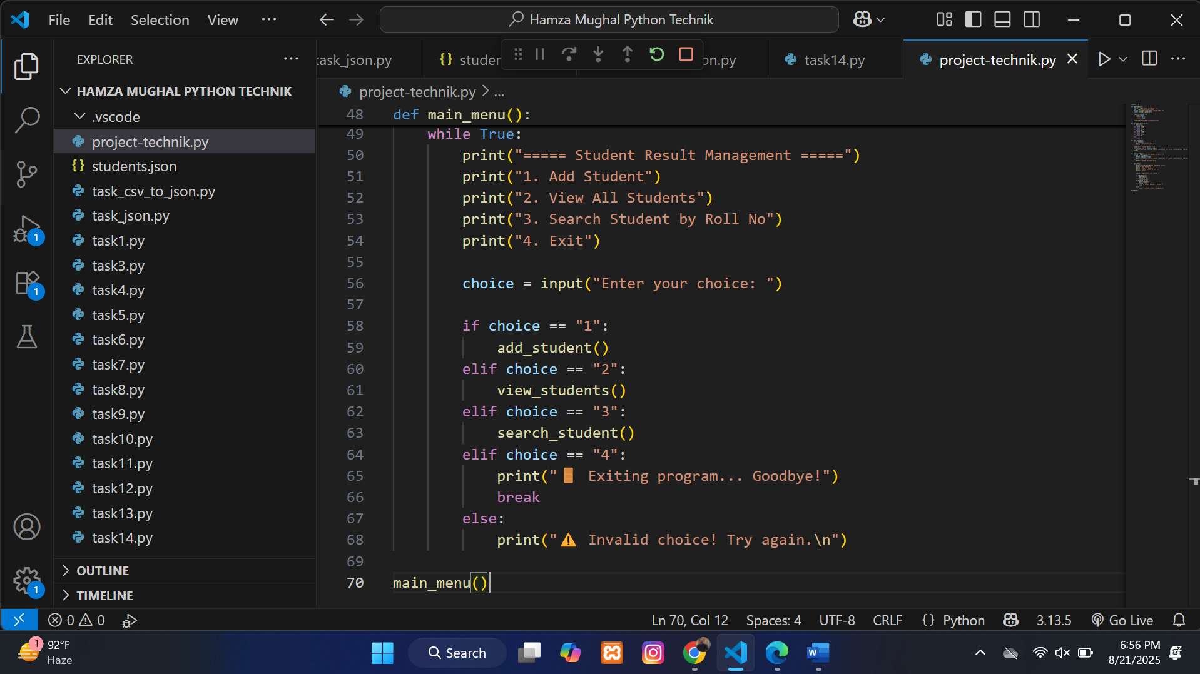

**Output:**

**Adding a student through option 1:**

**Again now going to check :**

**Selecting option 3 in order to search the student through roll no:**

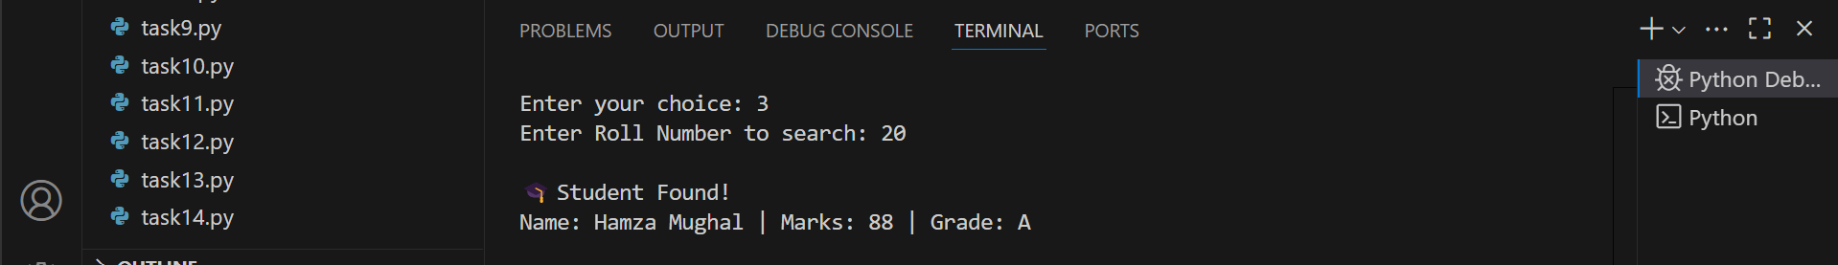

**Now viewing all students added in this management:**

